**WHY ORGANIC?**

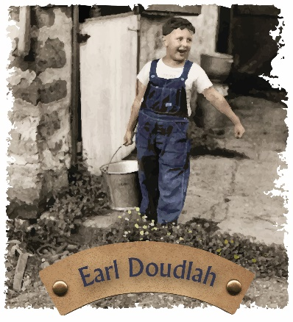

Doudlah Farms is Demeter Certified-Biodynamic ROC Certified-Regenerative, Beyond Organic and Certified Tested Clean. **Free of 220+ pesticides, Glyphosates and AMPA**.

Mark Doudlah a 5th along with son: Jason who is 6th generation Wisconsin farmers which transitioned to Organic during his father diagnosis of Cancer in 2008; Exposure to chemicals and pesticides lead to Earl Doudlah’s death in 2011. (Little Guy with Bucket). Doudlah Farms provides organic education to farm families and local communities to learn and participate in organic production of nutrient dense safe food; we’re the new **Rx for health. ENJOY**

Soil Health = Plant Health = Human Health